Week 3 Assignment
Name: Parth Milind Kulkarni
Student ID: CT_CSI_DE_1167
Objective:
Use Subqueries, CTEs, and Window Functions to analyze sales data from the Superstore dataset.

Tasks
Step 1: Setup Data
- Import the Superstore dataset into a table named superstore_raw.
Output:

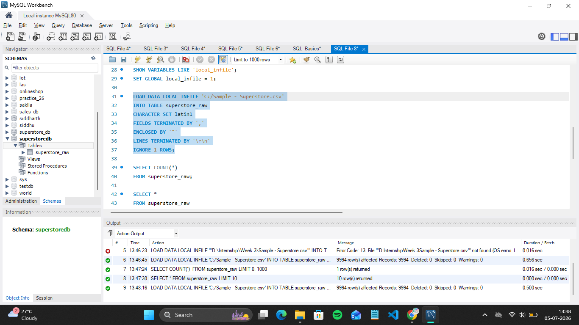
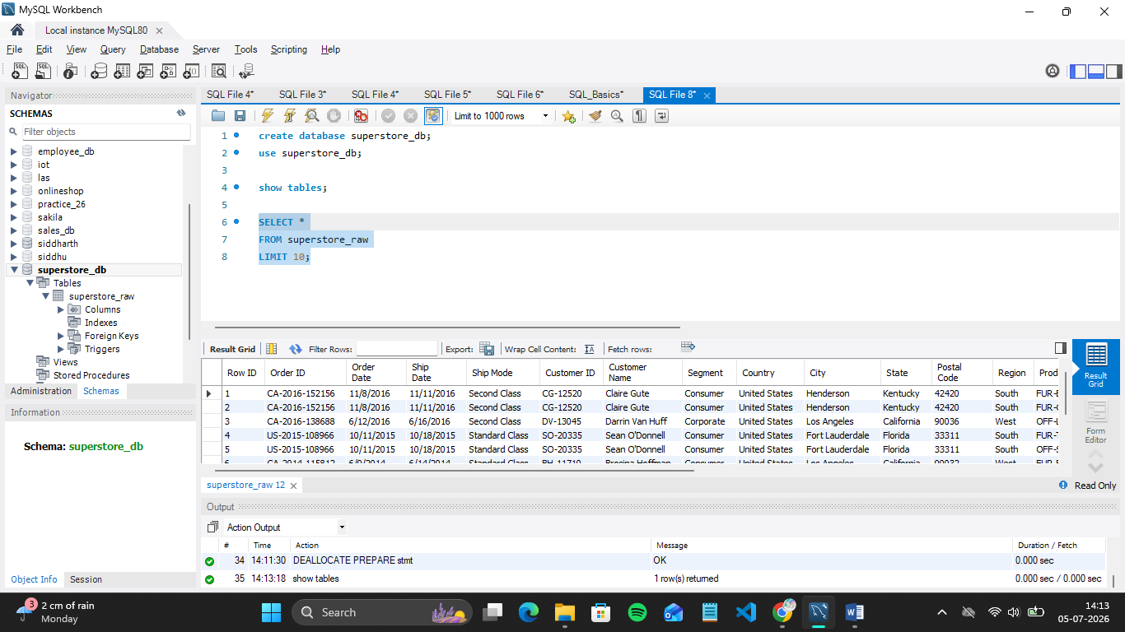
- Create these 3 tables from it:
  - customers Table :
SQL Query:
CREATE TABLE customers (
Customer_ID VARCHAR(20) PRIMARY KEY,
Customer_Name VARCHAR(100),
Segment VARCHAR(50),
Country VARCHAR(50),
City VARCHAR(50),
State VARCHAR(50),
Postal_Code VARCHAR(20),
Region VARCHAR(50)
);
Output:

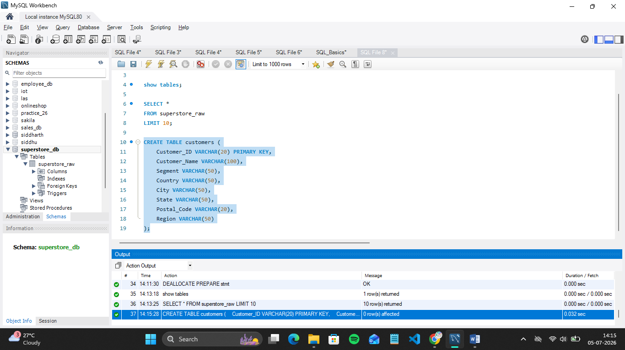

  - orders Table :
SQL Query:
CREATE TABLE orders (
Order_ID VARCHAR(20) PRIMARY KEY,
Order_Date DATE,
Ship_Date DATE,
Ship_Mode VARCHAR(50),
Customer_ID VARCHAR(20),

CONSTRAINT fk_customer
FOREIGN KEY (Customer_ID)
REFERENCES customers(Customer_ID)
);

Output:
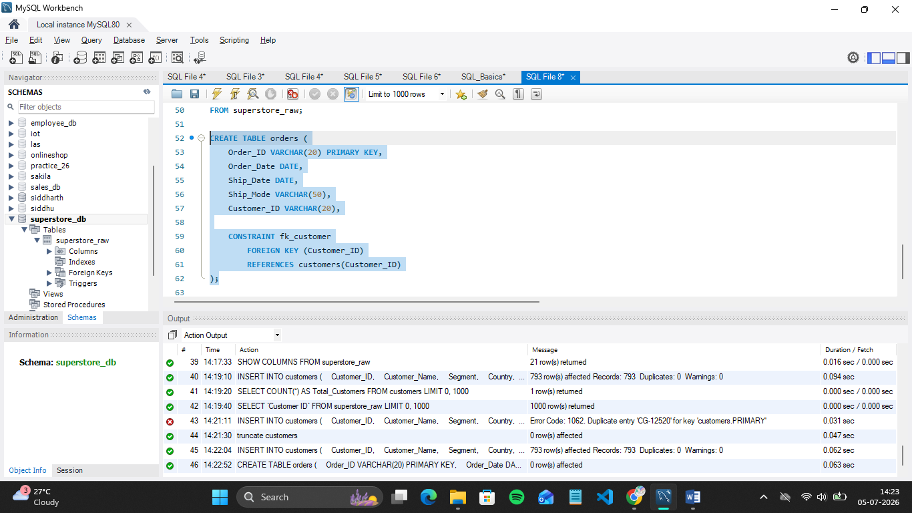

  - products Table:
SQL Query:
CREATE TABLE products (
Product_ID VARCHAR(30) PRIMARY KEY,
Category VARCHAR(50),
Sub_Category VARCHAR(50),
Product_Name VARCHAR(255)
);

Output:
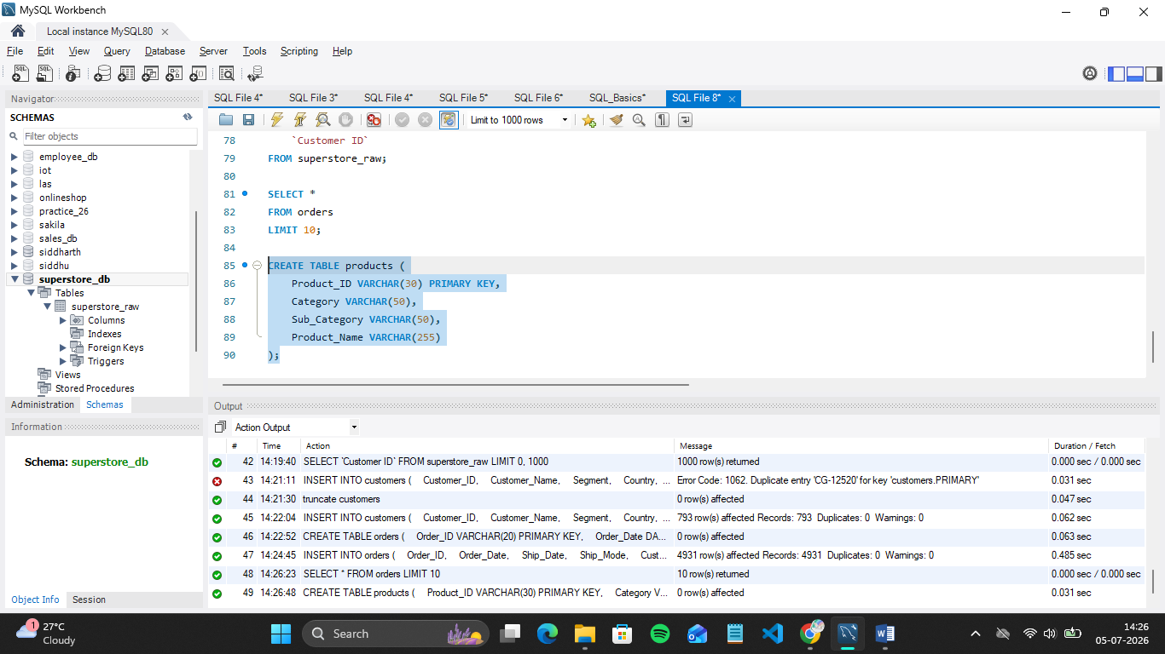
- Insert data into these tables using SELECT DISTINCT.

- Insert data into customers
SQL Query:
INSERT INTO customers
(
Customer_ID,
Customer_Name,
Segment,
Country,
City,
State,
Postal_Code,
Region
)
SELECT
`Customer ID`,
MAX(`Customer Name`),
MAX(`Segment`),
MAX(`Country`),
MAX(`City`),
MAX(`State`),
MAX(`Postal Code`),
MAX(`Region`)
FROM superstore_raw
GROUP BY `Customer ID`;

Output:

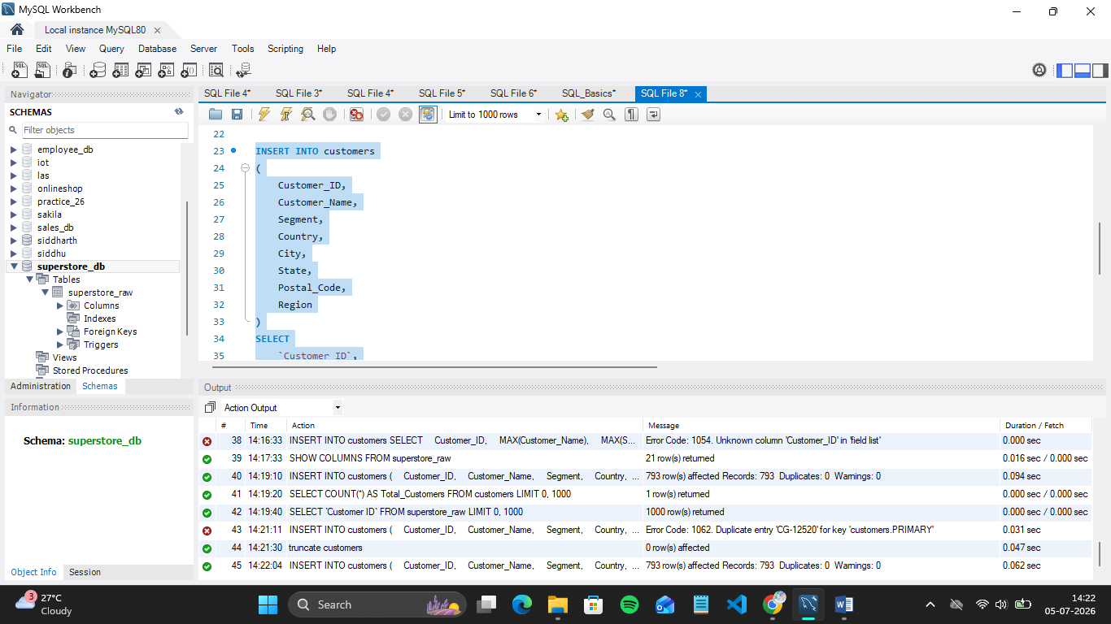

- Insert into orders Table:
SQL Query:
INSERT INTO orders
(
Order_ID,
Order_Date,
Ship_Date,
Ship_Mode,
Customer_ID
)

SELECT DISTINCT
`Order ID`,
STR_TO_DATE(`Order Date`, '%m/%d/%Y'),
STR_TO_DATE(`Ship Date`, '%m/%d/%Y'),
`Ship Mode`,
`Customer ID`
FROM superstore_raw;

Output:

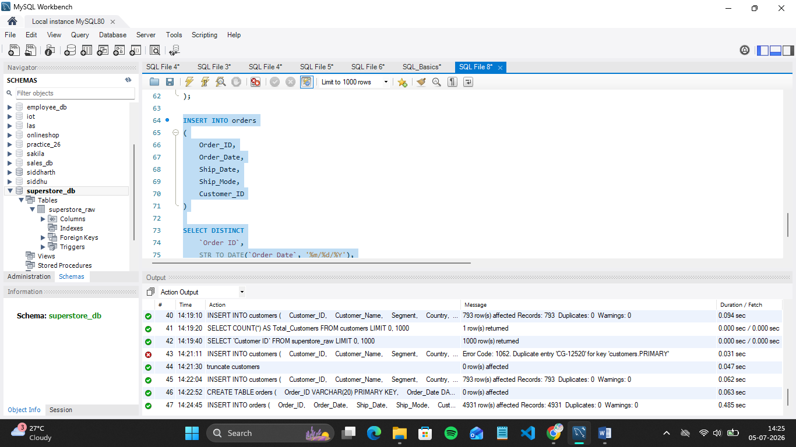

- Insert into products table:
SQL Query:
INSERT INTO products
(
Product_ID,
Category,
Sub_Category,
Product_Name
)
SELECT
`Product ID`,
MAX(`Category`),
MAX(`Sub-Category`),
MAX(`Product Name`)
FROM superstore_raw
GROUP BY `Product ID`;

Output:
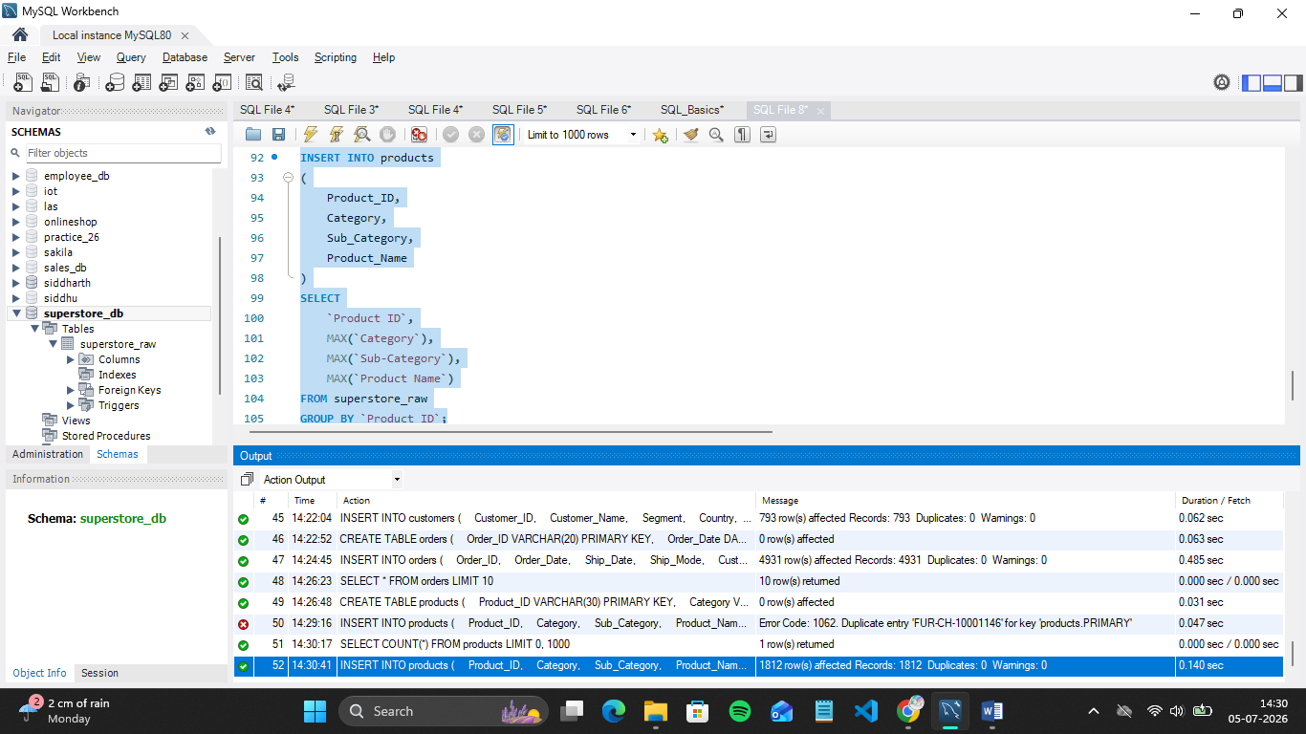

Step 2: Perform Required Queries

- Find all orders where sales are greater than the average sales. (Subquery)
SQL Query:
SELECT
o.Order_ID,
o.Customer_ID,
sr.`Sales`
FROM orders o
JOIN superstore_raw sr
ON o.Order_ID = sr.`Order ID`
WHERE sr.`Sales` >
(
SELECT AVG(`Sales`)
FROM superstore_raw
);

Output:
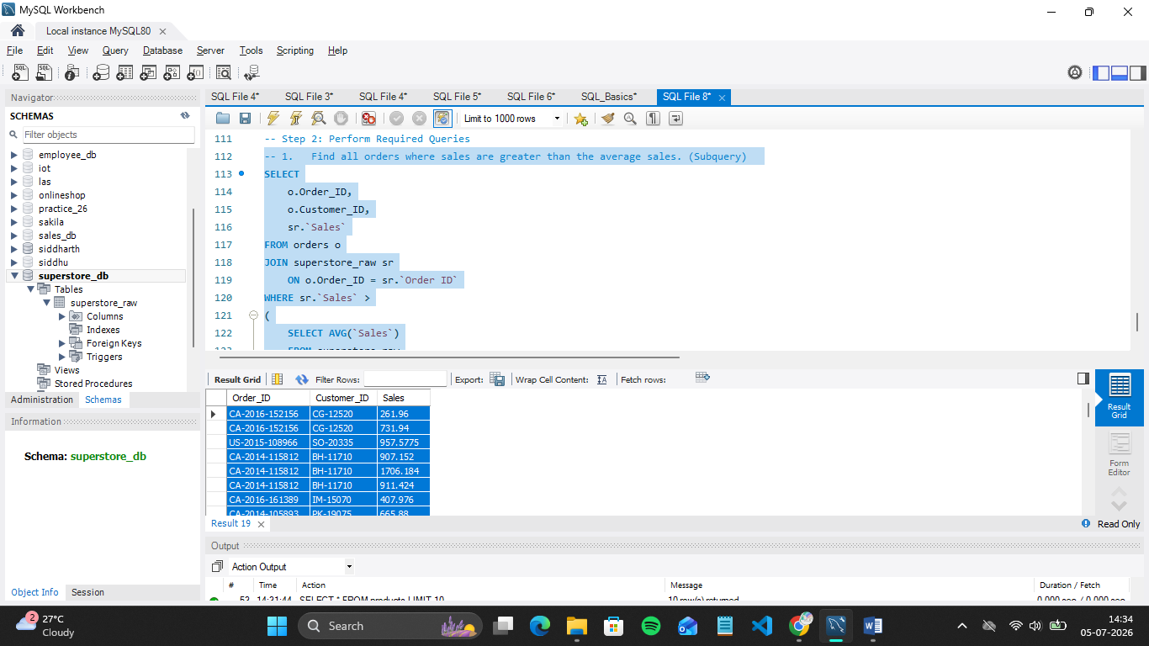

- Find the highest sales order for each customer. (Subquery)

SQL Query:
SELECT
c.Customer_Name,
o.Order_ID,
sr.Sales
FROM customers c
JOIN orders o
ON c.Customer_ID = o.Customer_ID
JOIN superstore_raw sr
ON o.Order_ID = sr.`Order ID`
WHERE (sr.`Customer ID`, sr.Sales) IN
(
SELECT
`Customer ID`,
MAX(Sales)
FROM superstore_raw
GROUP BY `Customer ID`
);

Output:

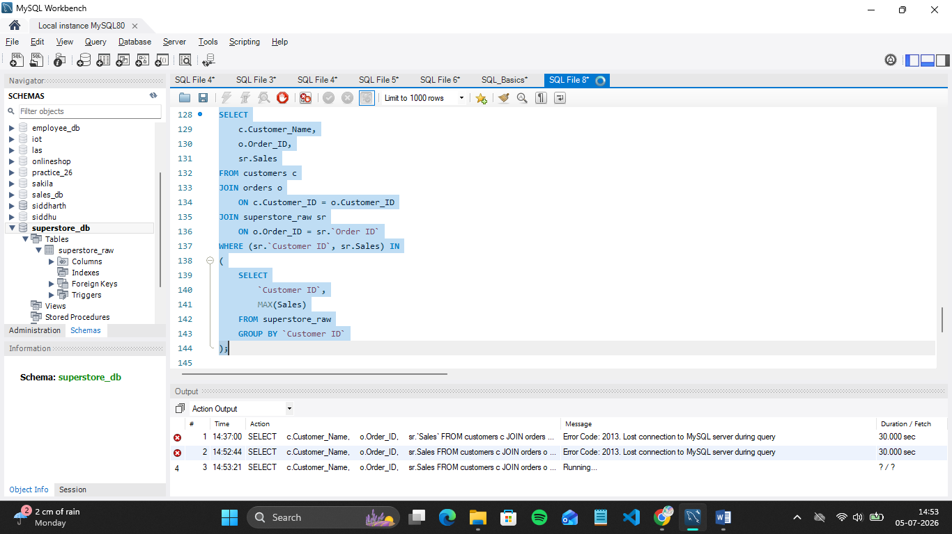

- Calculate total sales for each customer. (CTE)

SQL Query:
WITH CustomerSales AS
(
SELECT
c.Customer_ID,
c.Customer_Name,
SUM(sr.Sales) AS Total_Sales
FROM customers c
JOIN orders o
ON c.Customer_ID = o.Customer_ID
JOIN superstore_raw sr
ON o.Order_ID = sr.`Order ID`
GROUP BY
c.Customer_ID,
c.Customer_Name

SELECT *
FROM CustomerSales
ORDER BY Total_Sales DESC;

Output:

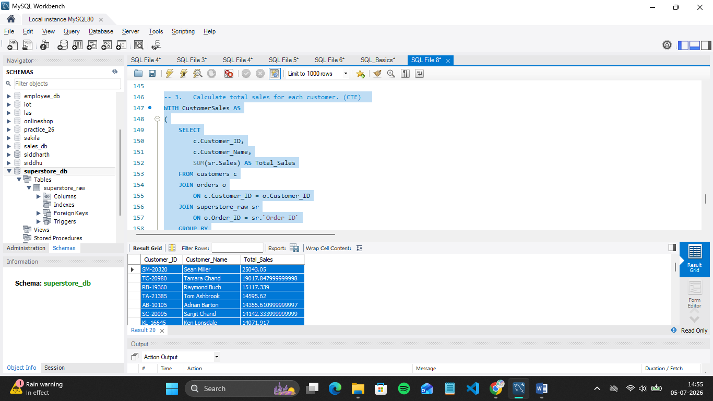

- Find customers whose total sales are above average. (CTE + Subquery)

SQL Query:
WITH CustomerSales AS
(
SELECT
c.Customer_ID,
c.Customer_Name,
SUM(sr.Sales) AS Total_Sales
FROM customers c
JOIN orders o
ON c.Customer_ID = o.Customer_ID
JOIN superstore_raw sr
ON o.Order_ID = sr.`Order ID`
GROUP BY
c.Customer_ID,
c.Customer_Name
)

SELECT
Customer_ID,
Customer_Name,
Total_Sales
FROM CustomerSales
WHERE Total_Sales >
(
SELECT AVG(Total_Sales)
FROM CustomerSales
)
ORDER BY Total_Sales DESC;

Output:
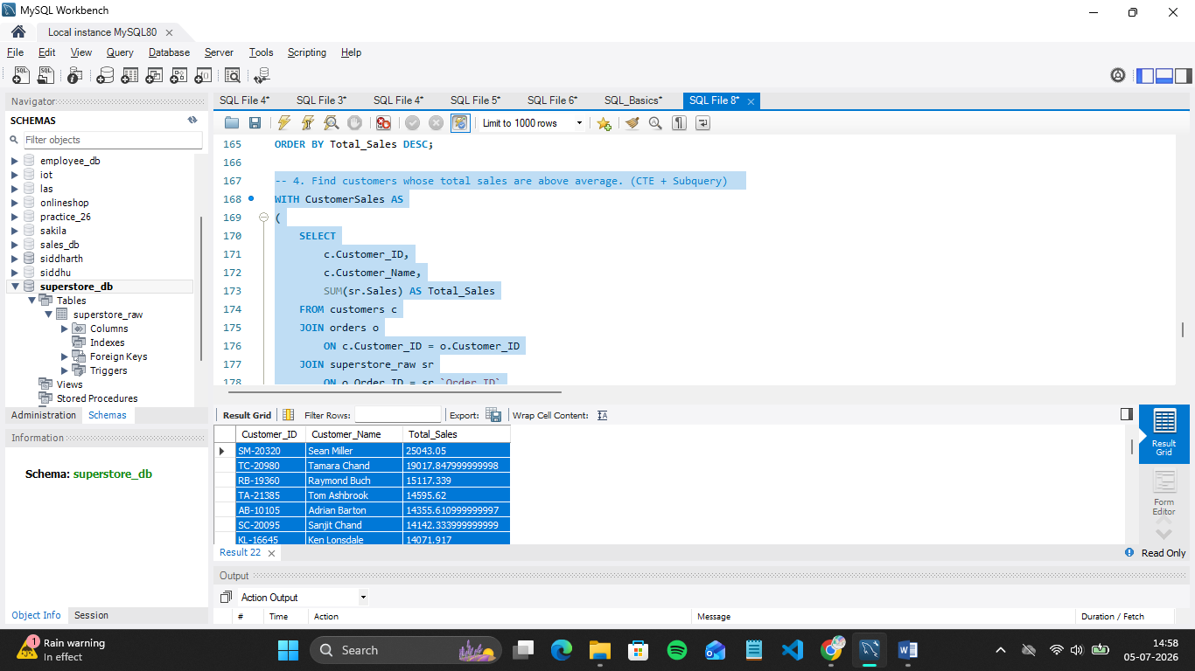

- Rank all customers based on total sales. (Window Function)

SQL Query:
WITH CustomerSales AS
(
SELECT
c.Customer_ID,
c.Customer_Name,
SUM(sr.Sales) AS Total_Sales
FROM customers c
JOIN orders o
ON c.Customer_ID = o.Customer_ID
JOIN superstore_raw sr
ON o.Order_ID = sr.`Order ID`
GROUP BY
c.Customer_ID,
c.Customer_Name
)

SELECT
Customer_ID,
Customer_Name,
Total_Sales,
RANK() OVER (ORDER BY Total_Sales DESC) AS Customer_Rank
FROM CustomerSales
ORDER BY Customer_Rank;
Output:
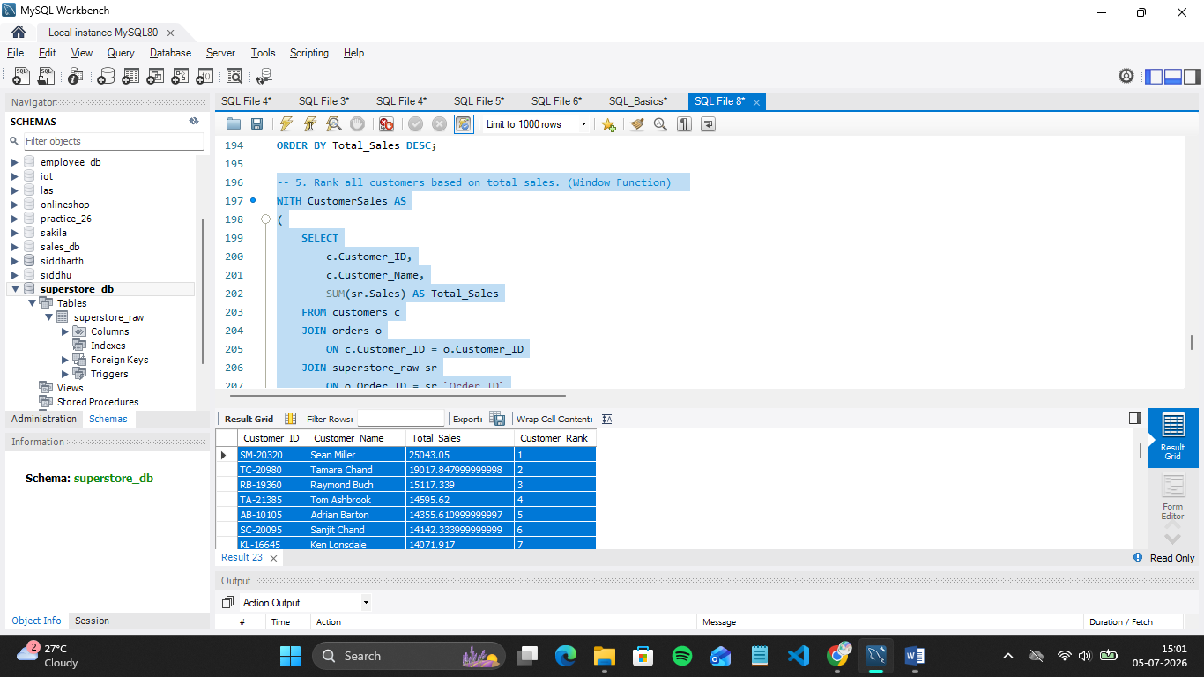

- Assign row numbers to each order within a customer. (Window Function + PARTITION BY)

SQL Query:
SELECT
Customer_ID,
Order_ID,
Order_Date,
ROW_NUMBER() OVER (
PARTITION BY Customer_ID
ORDER BY Order_Date
) AS Order_Number
FROM orders
ORDER BY Customer_ID, Order_Date;

Output:
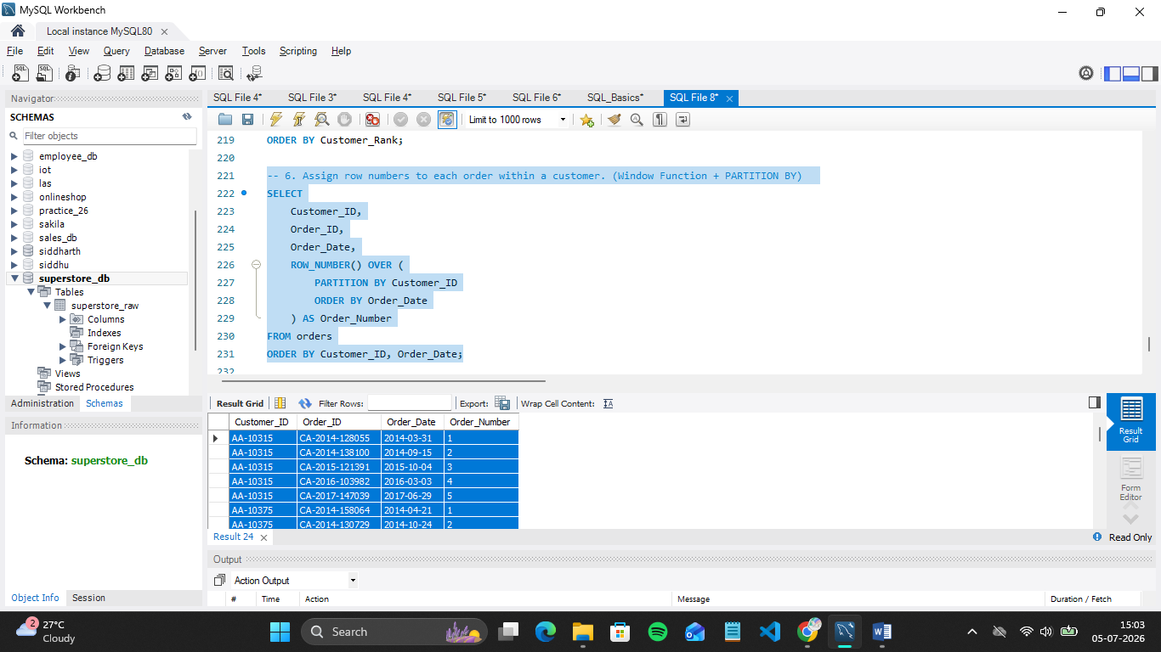

- Display top 3 customers based on total sales. (Window Function)

SQL Query:
WITH CustomerSales AS
(
SELECT
c.Customer_ID,
c.Customer_Name,
SUM(sr.Sales) AS Total_Sales
FROM customers c
JOIN orders o
ON c.Customer_ID = o.Customer_ID
JOIN superstore_raw sr
ON o.Order_ID = sr.`Order ID`
GROUP BY
c.Customer_ID,
c.Customer_Name
),

RankedCustomers AS
(
SELECT
Customer_ID,
Customer_Name,
Total_Sales,
RANK() OVER (ORDER BY Total_Sales DESC) AS Customer_Rank
FROM CustomerSales
)

SELECT
Customer_ID,
Customer_Name,
Total_Sales,
Customer_Rank
FROM RankedCustomers
WHERE Customer_Rank <= 3
ORDER BY Customer_Rank;

Output:
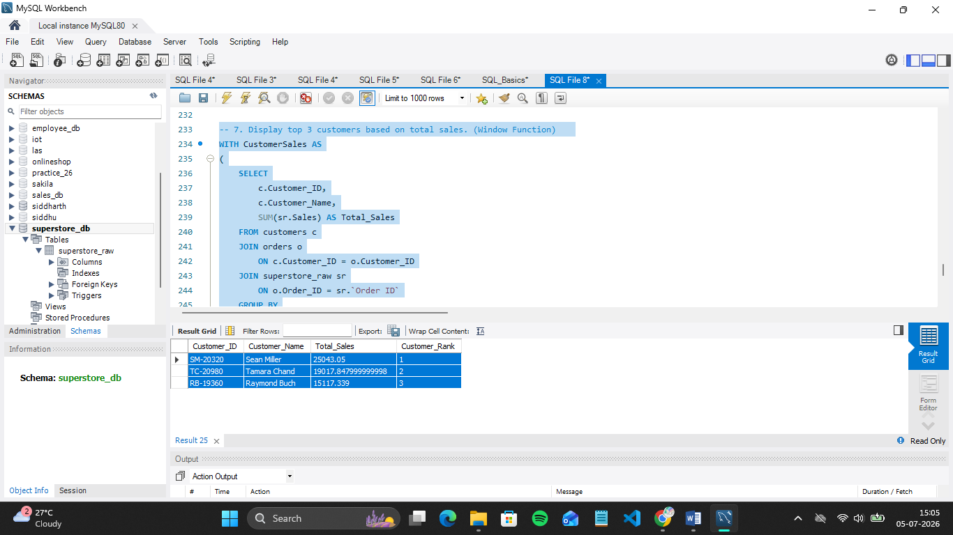

Step 3: Final Combined Query
Write one final query that shows:
- Customer Name
- Total Sales
- Rank
(Use JOIN + CTE + Window Function together)

SQL Query :

WITH CustomerSales AS
(
SELECT
c.Customer_ID,
c.Customer_Name,
SUM(sr.Sales) AS Total_Sales
FROM customers c
JOIN orders o
ON c.Customer_ID = o.Customer_ID
JOIN superstore_raw sr
ON o.Order_ID = sr.`Order ID`
GROUP BY
c.Customer_ID,
c.Customer_Name
)

SELECT
Customer_Name,
Total_Sales,
RANK() OVER (ORDER BY Total_Sales DESC) AS Customer_Rank
FROM CustomerSales
ORDER BY Customer_Rank;

Output:
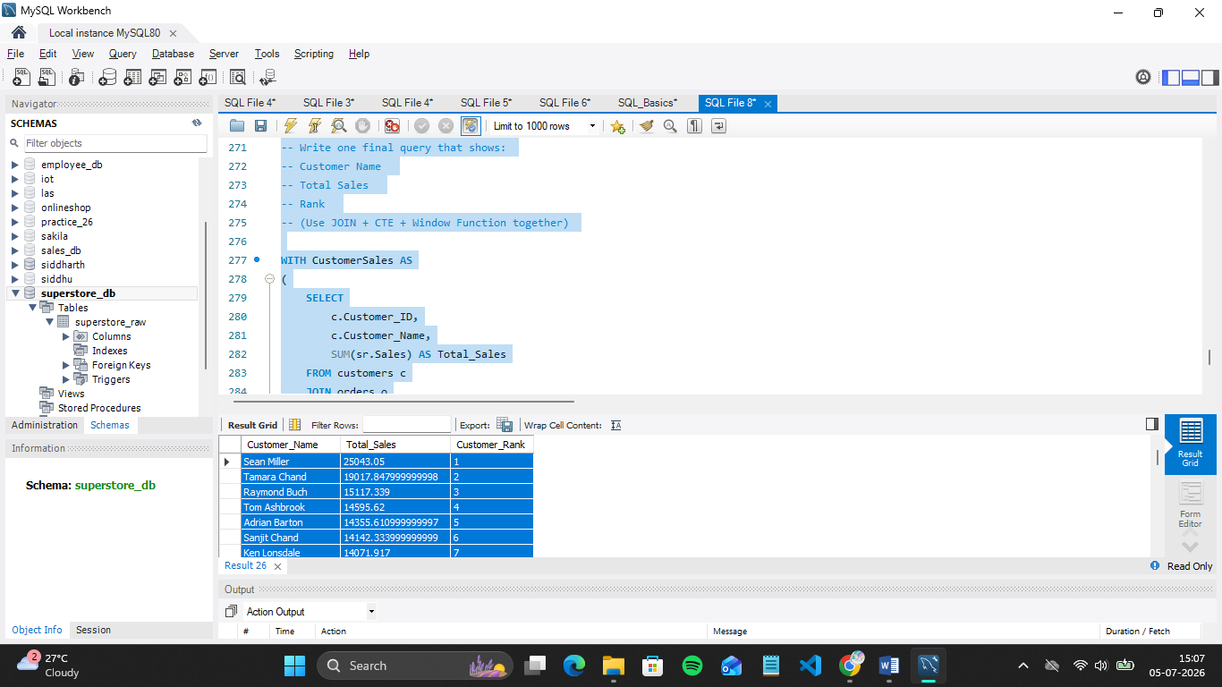
Mini Project: Customer Sales Insights
Answer the following using SQL:
- Who are the top 5 customers?

SQL Query:
WITH CustomerSales AS
(
SELECT
c.Customer_ID,
c.Customer_Name,
SUM(sr.Sales) AS Total_Sales
FROM customers c
JOIN orders o
ON c.Customer_ID = o.Customer_ID
JOIN superstore_raw sr
ON o.Order_ID = sr.`Order ID`
GROUP BY
c.Customer_ID,
c.Customer_Name
)

SELECT
Customer_ID,
Customer_Name,
Total_Sales
FROM CustomerSales
ORDER BY Total_Sales DESC
LIMIT 5;

Output:

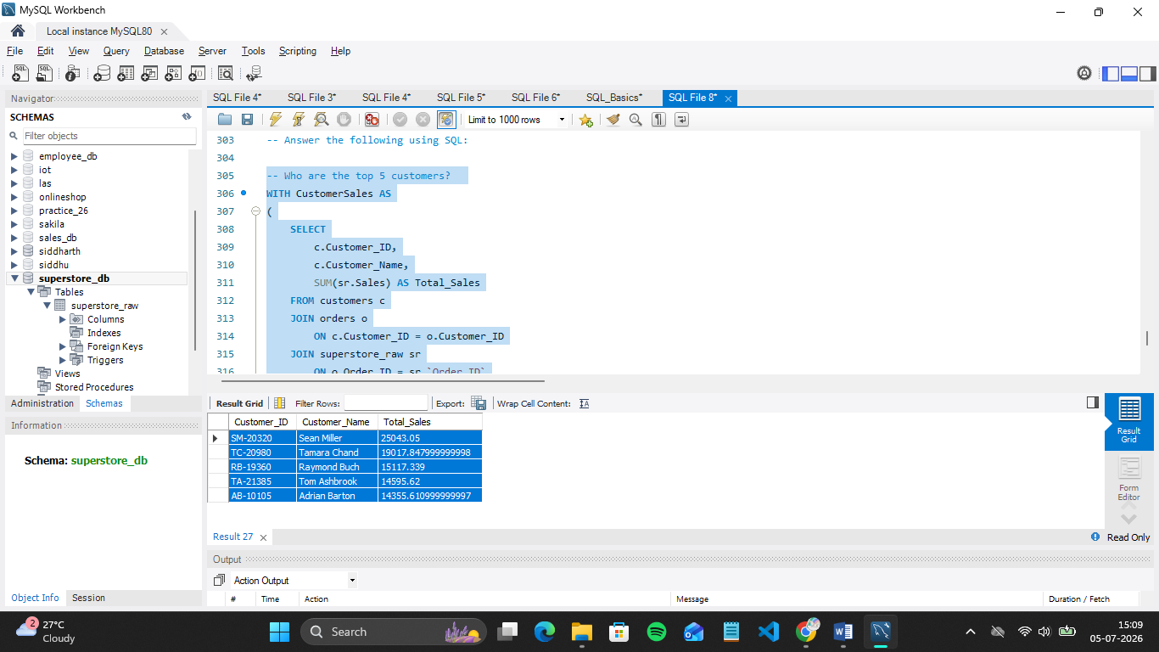

- Who are the bottom 5 customers?

SQL Query:
WITH CustomerSales AS
(
SELECT
c.Customer_ID,
c.Customer_Name,
SUM(sr.Sales) AS Total_Sales
FROM customers c
JOIN orders o
ON c.Customer_ID = o.Customer_ID
JOIN superstore_raw sr
ON o.Order_ID = sr.`Order ID`
GROUP BY
c.Customer_ID,
c.Customer_Name
)

SELECT
Customer_ID,
Customer_Name,
Total_Sales
FROM CustomerSales
ORDER BY Total_Sales ASC
LIMIT 5;

Output:
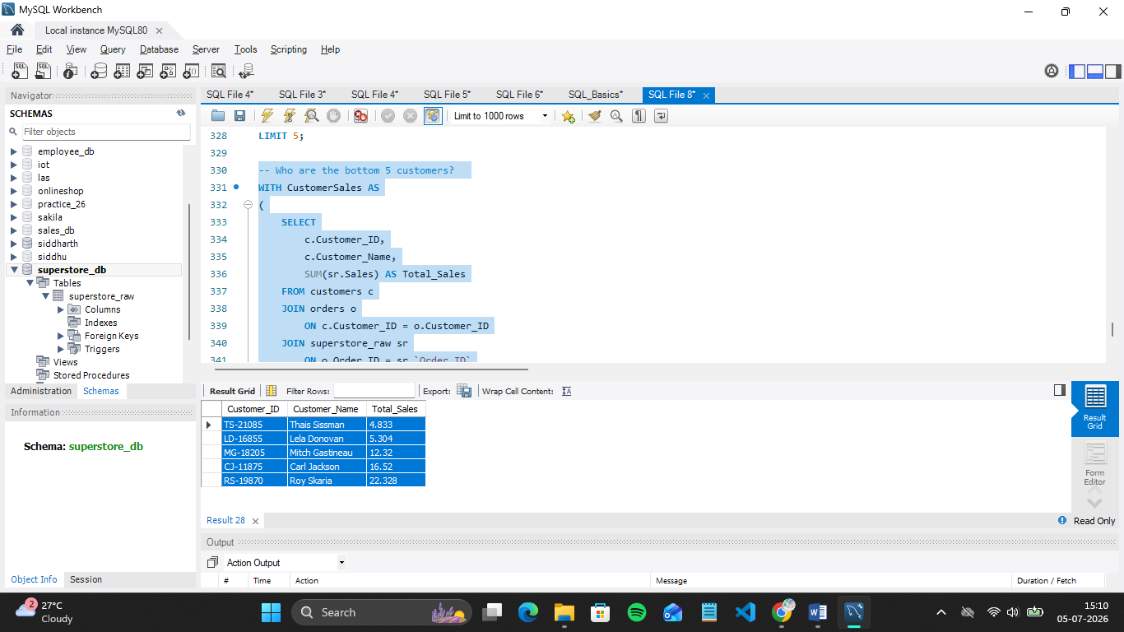

- Which customers made only one order?
SQL Query:
SELECT
c.Customer_ID,
c.Customer_Name,
COUNT(o.Order_ID) AS Total_Orders
FROM customers c
JOIN orders o
ON c.Customer_ID = o.Customer_ID
GROUP BY
c.Customer_ID,
c.Customer_Name
HAVING COUNT(o.Order_ID) = 1;

Output:
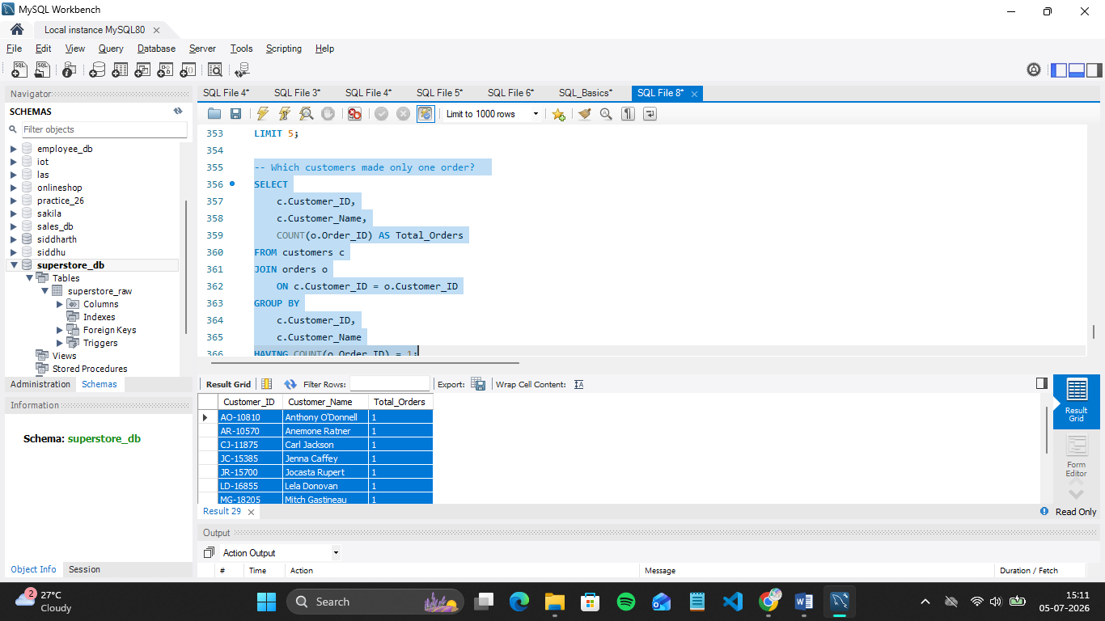

- Which customers have above-average sales?

SQL Query:
WITH CustomerSales AS
(
SELECT
c.Customer_ID,
c.Customer_Name,
SUM(sr.Sales) AS Total_Sales
FROM customers c
JOIN orders o
ON c.Customer_ID = o.Customer_ID
JOIN superstore_raw sr
ON o.Order_ID = sr.`Order ID`
GROUP BY
c.Customer_ID,
c.Customer_Name
)

SELECT
Customer_ID,
Customer_Name,
Total_Sales
FROM CustomerSales
WHERE Total_Sales >
(
SELECT AVG(Total_Sales)
FROM CustomerSales
)
ORDER BY Total_Sales DESC;

Output:

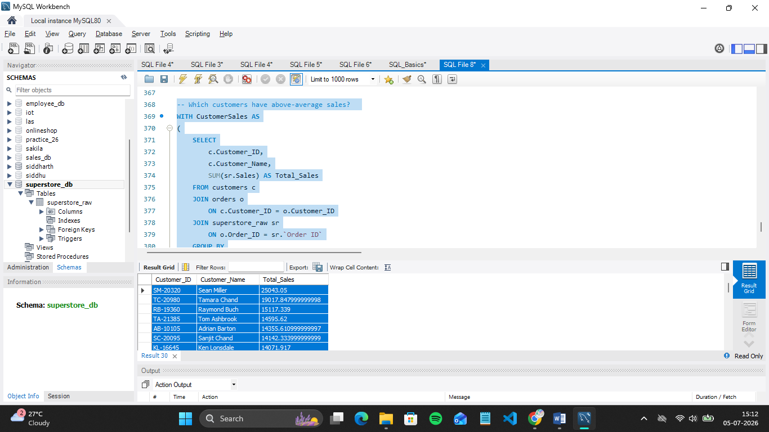

- What is the highest order value per customer?

SQL Query:
SELECT
c.Customer_ID,
c.Customer_Name,
MAX(sr.Sales) AS Highest_Order_Value
FROM customers c
JOIN orders o
ON c.Customer_ID = o.Customer_ID
JOIN superstore_raw sr
ON o.Order_ID = sr.`Order ID`
GROUP BY
c.Customer_ID,
c.Customer_Name
ORDER BY Highest_Order_Value DESC;
Output:

